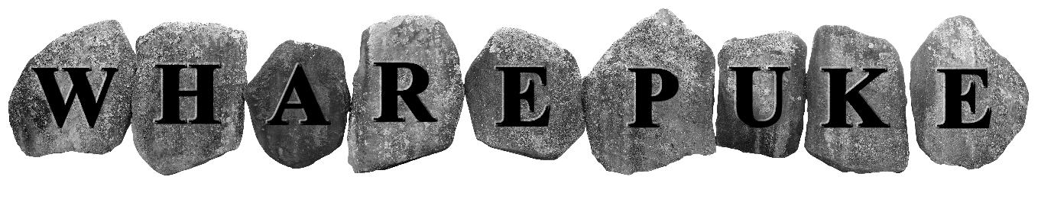
5th International Open Printmaking Show 2017/18
Deadline for entries November 5th, 2017
APPLICATION FORM
Up to 2 entries per artist initially by email. There is no minimum size requirement but due to constraints of space only works up to 1000 x 1000 mm (paper size) can be accommodated.
NAME: Click or tap here to enter text.

ADDRESS For return of work and catalogue: Click or tap here to enter text.
EMAIL ADDRESS: Click or tap here to enter text.
Where did you hear about the show? Click or tap here to enter text.

WORK 1

TITLE Click or tap here to enter text.
MEDIUM Click or tap here to enter text.
SIZE Click or tap here to enter text.
DATE Click or tap here to enter text.
EDITION No. Click or tap here to enter text. No. Available Click or tap here to enter text.
PRICE IN $NZ – including %40 Commission Click or tap here to enter text.
ANY SPECIAL HANGING REQUIREMENTS? Click or tap here to enter text.
CAN WORK BE PINNED? Click or tap here to enter text.

WORK 2

TITLE Click or tap here to enter text.
MEDIUM Click or tap here to enter text.
SIZE Click or tap here to enter text.
DATE Click or tap here to enter text.
EDITION No. Click or tap here to enter text. No. Available Click or tap here to enter text.
PRICE IN $NZ – including %40 Commission Click or tap here to enter text.
ANY SPECIAL HANGING REQUIREMENTS? Click or tap here to enter text.
CAN WORK BE PINNED? Click or tap here to enter text.

Check List:
Please email the following to
info@art-at-wharepuke.co.nz
Application Form
Images – please label with name, title and number as per application form
Entry Fee paid
C.V

NZ based artists only:
For direct credit entry fees:
ANZ Kerikeri - 01- 0382-0082741-00 (please include name as reference)

N.B Deadline for email entries is November 5th, 2017
Accepted artists will be notified by November 12th via email provided on application form

